Dashboard Insights — Toronto Crime Analytics Dashboard
The Toronto Crime Analytics Dashboard provides an overview of crime activity in Toronto using a clean dataset with 467,867 records and 31 columns. The dashboard summarizes key crime indicators, high-risk locations, common crime types, peak crime periods, police division activity, and year-over-year crime trends.

Overview Insight
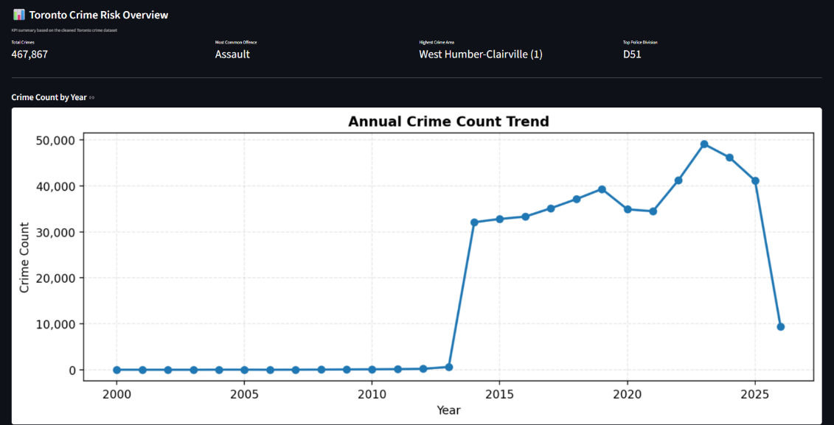
The Overview page shows that the dataset contains 467,867 total crime records. The most common offence is Assault, which indicates that violent/person-related incidents are a major crime category in the dataset. The neighbourhood with the highest crime count is West Humber-Clairville (1), while the police division with the highest activity is D51. These KPI cards help users quickly identify the most important crime patterns before exploring the detailed pages.

High-Risk Neighbourhoods Insight
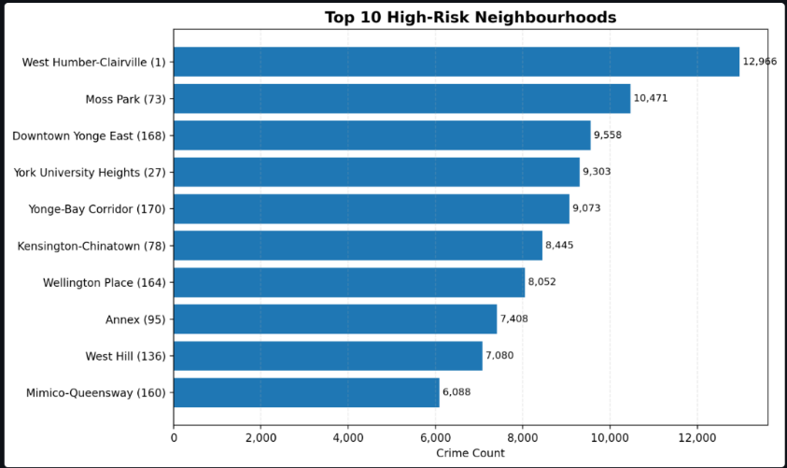
The High-Risk Neighbourhoods page shows that West Humber-Clairville (1) has the highest crime count with 12,966 incidents. It is followed by Moss Park (73) with 10,471 incidents and Downtown Yonge East (168) with 9,558 incidents. This suggests that crime activity is concentrated in specific neighbourhoods rather than evenly distributed across the city. These areas may require closer monitoring, stronger community safety programs, or more focused police resource planning.
Crime Types Insight
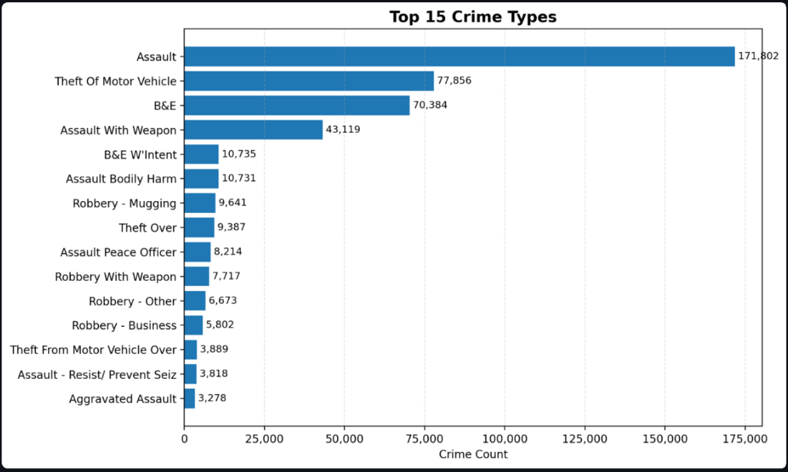
The Crime Types page shows that Assault is the most frequent offence, with 171,802 cases, making it the dominant crime type in the dataset. The next highest crime types are Theft of Motor Vehicle with 77,856 cases and B&E with 70,384 cases. This means that the dashboard highlights two major concerns: personal safety incidents and property-related crimes. Since Assault is much higher than other offences, it should be treated as a priority area for deeper analysis.
Peak Crime Periods Insight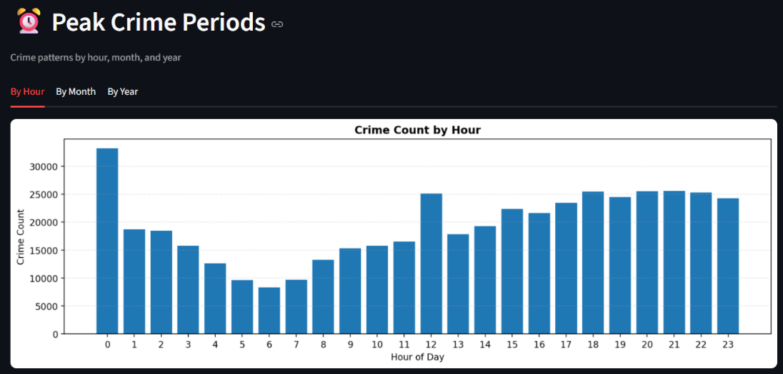
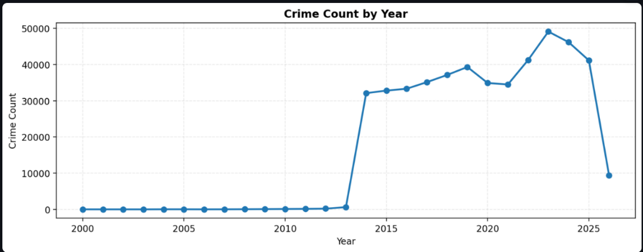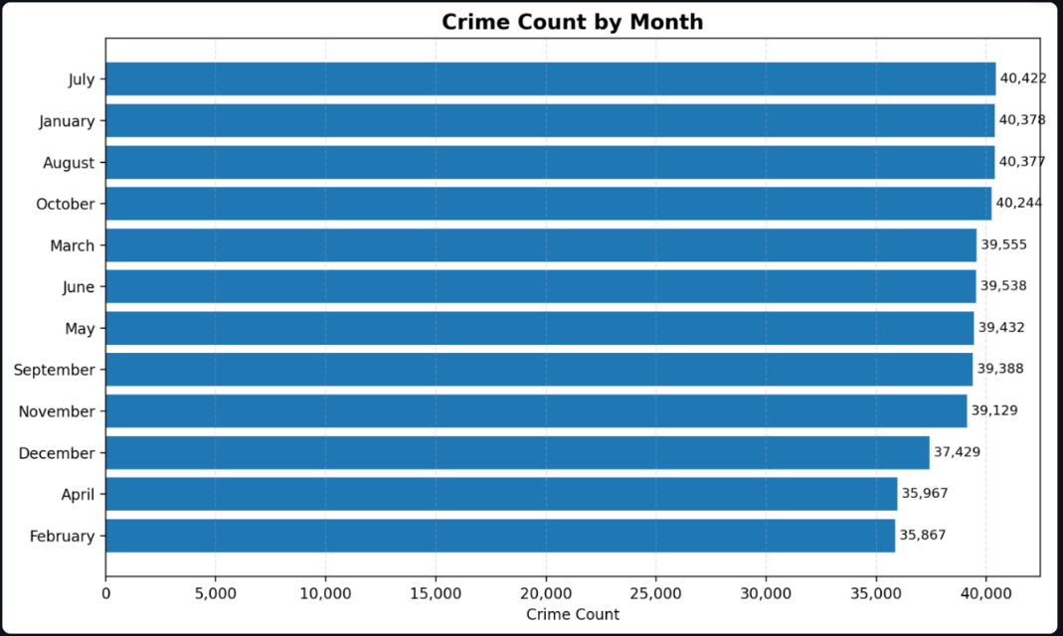
The Peak Crime Periods page shows crime patterns by hour. The highest activity appears around hour 0, with another strong pattern from the afternoon to evening hours, especially around 12 PM and 6 PM to 10 PM. This suggests that crime is not limited to late-night hours only. It also occurs during active daytime and evening periods when people are commuting, working, or gathered in public areas. These insights can help in planning patrol schedules or identifying time periods that need stronger monitoring.
Police Division Activity Insight
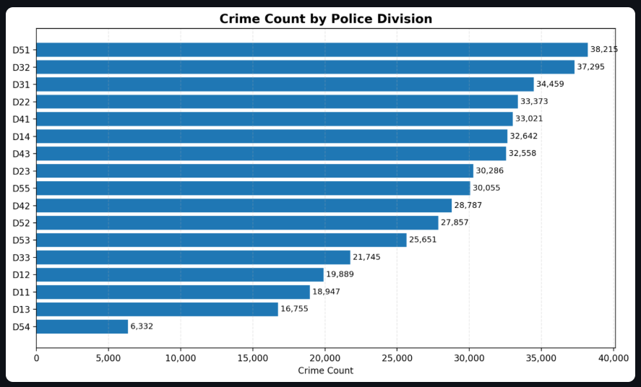
The Police Division Activity page shows that D51 has the highest crime count with 38,215 incidents. It is followed by D32 with 37,295 incidents, D31 with 34,459 incidents, D22 with 33,373 incidents, and D41 with 33,021 incidents. This shows that some police divisions handle much higher crime volumes than others. D51, D32, and D31 may require more resources, staffing, or operational attention compared to divisions with lower crime counts.
Year-over-Year Trend Insight
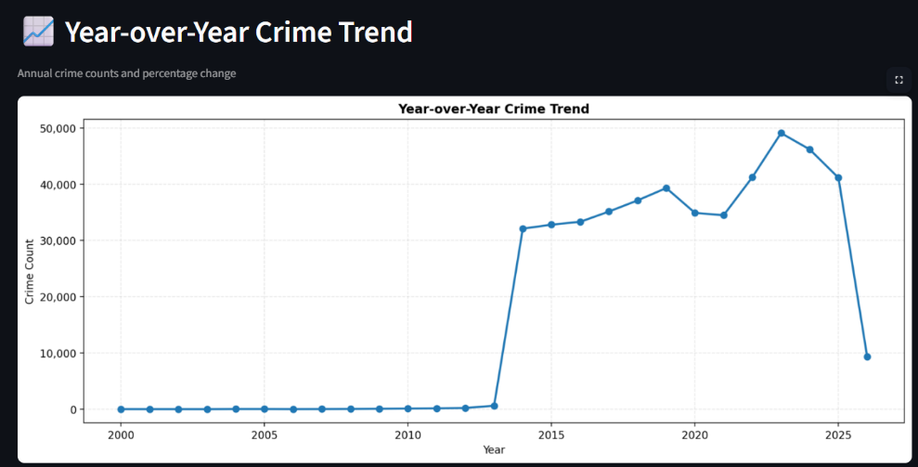
The Year-over-Year Crime Trend page shows that crime counts were very low before 2014, then sharply increased around 2014. From 2014 onward, crime counts generally increased, reaching the highest point around 2023, before decreasing in the later years. The sharp drop near 2026 may be due to incomplete data for the latest year, so it should be interpreted carefully. Overall, the trend suggests that crime activity increased significantly over time, especially between 2014 and 2023.
Overall Dashboard Insight
Overall, the dashboard shows that Toronto crime activity is concentrated in specific neighbourhoods, offence types, and police divisions. Assault is the most common crime type, West Humber-Clairville is the highest-crime neighbourhood, and D51 is the most active police division. The dashboard also shows useful time-based patterns, helping users understand when crime is most likely to occur. These insights make the dashboard useful for crime monitoring, public safety planning, resource allocation, and identifying areas that need further investigation.

